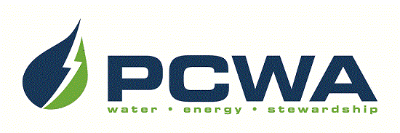

JOIN OUR OUTSTANDING TEAM OF PROFESSIONALS!
Placer County Water Agency encompasses the entire, 1,500-square-mile boundary of Placer County, ranging from the rim of the Sacramento Valley on the west to the Sierra Nevada and Lake Tahoe on the east. The Agency is headquartered in Auburn and carries out a broad range of responsibilities including water resource planning and management, retail and wholesale supply of irrigation water and drinking water, production of hydroelectric power and watershed stewardship across Placer County. We are seeking talented candidates to join our team for the position of:

Instrumentation Technician
$90,278 - $115,211 annually, DOQ, plus excellent benefits

PCWA is seeking a highly skilled individual to join its Drinking Water Operations Electrical Maintenance team as a Water Quality Instrumentation Technician. The incumbent will install, calibrate, test, maintain and repair a variety of recording, control, telemetry sampling and metering devices related to water treatment and distribution systems. Our ideal candidate will possess journey level experience in the installation, maintenance and repair of instrumentation common to a water treatment and distribution system and will have completed a recognized apprenticeship program in the electrical/instrumentation field or the equivalent of an Associate’s degree in electronics. Visit our website for detailed recruitment information and to complete the on-line application: www.pcwa.net.
Applications must be received by 5:00pm Monday, March 25, 2024.
Use your smart phone to scan this image
to be taken to PCWA’s Careers page!

PCWA is an Equal Opportunity Employer.

