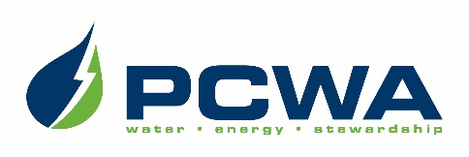

JOIN OUR OUTSTANDING TEAM OF PROFESSIONALS!
Placer County Water Agency encompasses the entire, 1,500-square-mile boundary of Placer County, ranging from the rim of the Sacramento Valley on the west to the Sierra Nevada and Lake Tahoe on the east.
The Agency is headquartered in Auburn and carries out a broad range of responsibilities including water resource planning and management, retail and wholesale supply of irrigation water and drinking water, production of hydroelectric power and watershed stewardship across Placer County.
We are seeking candidates for the position of:

DEPUTY DIRECTOR OF POWER GENERATION SERVICES
(ENGINEERING AND LICENSING)
$154,302 - $196,932 annually, DOQ, plus excellent benefits

PCWA is seeking an energetic individual to assist the Director of Power Generation Services in organizing, directing and coordinating departmental activities in support of the Agency’s multi-purpose power generating facilities. This position will assist in coordinating the engineering and licensing activities with other departments and outside stakeholders and providing technical expertise for Agency operations of the Agency’s Middle Fork American River Project. Our ideal candidate will possess a Bachelor’s Degree in Electrical, Civil or Mechanical Engineering or a closely related field, plus five years of increasingly responsible professional engineering experience with two years of administrative and management responsibility. Registration as a Professional Engineer in the State of California is preferred.
Applications and resumes must be received by 11:59 p.m. Friday, March 8, 2024.
Use your smart phone to scan this image
to be taken to PCWA’s Careers page!

PCWA is an Equal Opportunity Employer.

