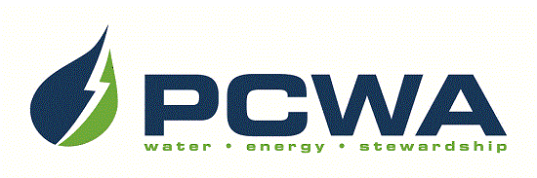

JOIN OUR OUTSTANDING TEAM OF PROFESSIONALS!
Placer County Water Agency encompasses the entire, 1,500-square-mile boundary of Placer County, ranging from the rim of the Sacramento Valley on the west to the Sierra Nevada and Lake Tahoe on the east. The Agency is headquartered in Auburn and carries out a broad range of responsibilities including water resource planning and management, retail and wholesale supply of irrigation water and drinking water, production of hydroelectric power and watershed stewardship across Placer County. We are seeking talented candidates to join our team for the position of:

DEPUTY DIRECTOR OF INFORMATION TECHNOLOGIES
$136,366 - $174,046 annually, DOQ, plus excellent benefits

PCWA is seeking a collaborative, hands-on leader for its Information Technology Division, responsible for developing, implementing, and day-to-day oversight of procedures, protocols, and controls designed to protect the Agency’s information assets. Our ideal candidate will possess progressively responsible professional-level information technology experience in a wide array of IT security areas, including security awareness, risk assessment, business impact analysis, disaster recovery and business continuity, with at least two years of experience managing an information security program and a Bachelor’s degree in computer science, information technology or a related field. Visit our website for detailed recruitment information and to complete the on-line application: www.pcwa.net.

Applications and resumes must be received by 5:00 p.m. Friday, February 2, 2024.
Use your smart phone to scan this image
to be taken to PCWA’s Careers page!

PCWA is an Equal Opportunity Employer.

