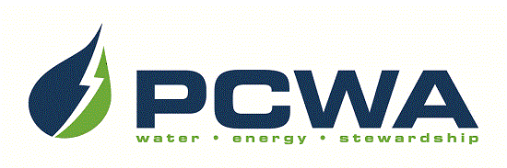

JOIN OUR OUTSTANDING TEAM OF PROFESSIONALS!
Placer County Water Agency encompasses the entire, 1,500-square-mile boundary of Placer County, ranging from the rim of the Sacramento Valley on the west to the Sierra Nevada and Lake Tahoe on the east. The Agency is headquartered in Auburn and carries out a broad range of responsibilities including water resource planning and management, retail and wholesale supply of irrigation water and drinking water, production of hydroelectric power and watershed stewardship across Placer County. We are seeking talented candidates to join our team for the position of:

CANAL OPERATOR I
$4,849 – $6,188 monthly, DOQ, plus excellent benefits

PCWA is seeking an engaged individual to join its Field Services Department to operate and maintain the Agency’s canals and related raw water system. The ideal candidate will possess increasingly responsible experience operating a canal/raw water system similar to the Agency’s, including having had responsibility for regulating water in canals and through spills, and patrolling canals. Possession of a valid California State Water Resources Control Board Water Distribution Operators Certificate, Grade 1 is required; possession of a Grade 2 or higher is desirable. Visit our website for detailed recruitment information and to complete the on-line application: www.pcwa.net.
Applications must be received on/before Thursday, February 1st, 2024.
Use your smart phone to scan this image
to be taken to PCWA’s Careers page!

PCWA is an Equal Opportunity Employer.

