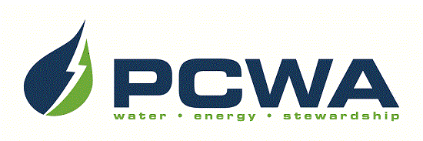

JOIN OUR OUTSTANDING TEAM OF PROFESSIONALS!
Placer County Water Agency encompasses the entire, 1,500-square-mile boundary of Placer County, ranging from the rim of the Sacramento Valley on the west to the Sierra Nevada and Lake Tahoe on the east. The Agency is headquartered in Auburn and carries out a broad range of responsibilities including water resource planning and management, retail and wholesale supply of irrigation water and drinking water, production of hydroelectric power and watershed stewardship across Placer County. We are seeking talented candidates to join our team for the position of:

INSPECTOR II
$73,852 – $94,263 annually, DOQ, plus excellent benefits

PCWA is seeking talented, skilled candidates to join its Technical Services department to perform construction inspection duties for a variety of capital improvement, facilities and infrastructure projects. Our ideal candidate will possess increasingly responsible experience performing construction inspection duties in a water system or comparable environment. Possession of a valid California driver’s license and acceptable driving record is required; possession of a State Water Resources Control Board Water Distribution Operators Certificate, Grade 1 (or higher) is desirable. Visit our website for detailed recruitment information and to complete the on-line application: www.pcwa.net.
Applications must be received on/before 5:00pm, Tuesday, December 19, 2023.

Use your smart phone to scan this image
to be taken to PCWA’s Careers page!

PCWA is an Equal Opportunity Employer.

